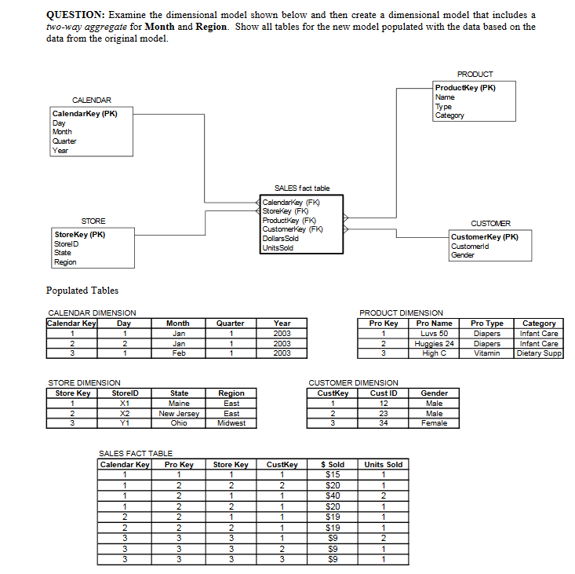

Steps to produce the dimensional model:

* Identify the business process (Regional Sales of Products)
* Establish the grain (Revenue in Dollars based on Units sold)
* Chart the dimensions (Month, Region, Customer, Product)
* Identify the facts (Revenue in Dollars and Product Units Sold)

In the following two way aggregate model we can see that we have the month, region customer and product dimensions. Each dimension has a surrogate key which is the primary key in the dimension table. This surrogate key is also the foreign key in the Sales fact table. In the sales fact table we record the revenue in dollars and the units sold, apart from this we also have references to the surrogate keys for the dimension tables.

The two way aggregate is based on the Month and the Region of the base dimensions. From the business perspective we can generate reports on the monthly revenue in dollars for particular products for each region.

